## Question – Explain LSTM (Long Short Term Memory )

Answer - Long Short Term Memory is a kind of recurrent neural network. In RNN output from the last step is fed as input in the current step. LSTM was desgined by Hochreiter&Schmidhuber. It tackled the problem of long-term dependencies of RNN in which the RNN cannot predict the word stored in the long term memory but can give more accurate predictions from the recent information. As the gap length increases RNN does not give efficent performance. LSTM can by default retain the information for long period of time. It is used for processing, predicting and classifying on the basis of time series data.

#### Structure Of LSTM:

LSTM has a chain structure that contains four neural networks and different memory blocks called **cells**.

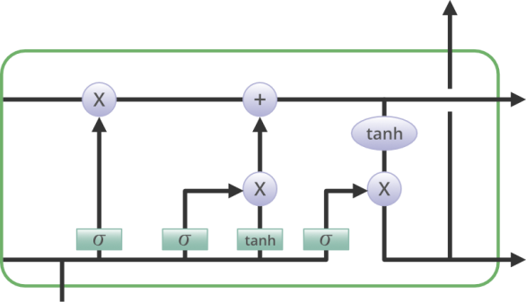

Information is retained by the cells and the memory manipulations are done by the **gates.** There are three gates –

1. - **Forget Gate:** The information that no longer useful in the cell state is removed with the forget gate. Two inputs *x_t* (input at the particular time) and *h_t-1* (previous cell output) are fed to the gate and multiplied with weight matrices followed by the addition of bias. The resultant is passed through an activation function which gives a binary output. If for a particular cell state the output is 0, the piece of information is forgotten and for the output 1, the information is retained for the future use.

2 –

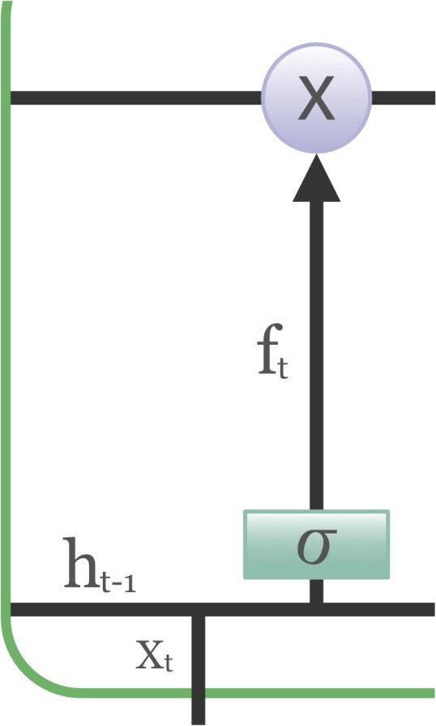

1. - **Input gate:** Addition of useful information to the cell state is done by input gate. First, the information is regulated using the sigmoid function and filter the values to be remembered similar to the forget gate using inputs *h_t-1* and *x_t*. Then, a vector is created using *tanh* function that gives output from -1 to +1, which contains all the possible values from h_t-1 and *x_t*. Atlast, the values of the vector and the regulated values are multiplied to obtain the useful information

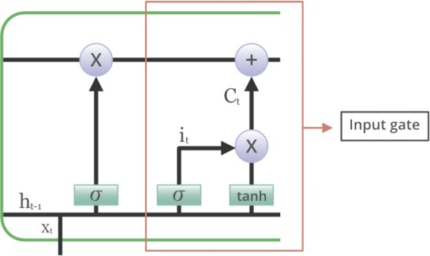

1. **- Output gate:** The task of extracting useful information from the current cell state to be presented as an output is done by output gate. First, a vector is generated by applying tanh function on the cell. Then, the information is regulated using the sigmoid function and filter the values to be remembered

using inputs *h_t-1* and *x_t*. Atlast, the values of the vector and the regulated values are multiplied to be sent as an output and input to the next cell.

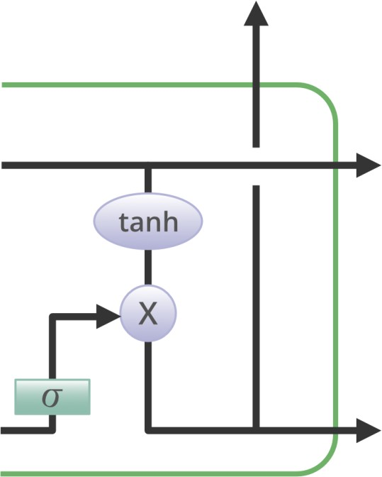

#### Some of the famous applications of LSTM includes:

1. Language Modeling
2. Machine Translation
3. Image Captioning
4. Handwriting generation
5. Question Answering Chatbots

## Question – What is deep learning , Explain its uses and application and history.

Answer - **Deep learning** is a subset of **machine learning** where artificial **neural networks**, algorithms inspired by the human brain, **learn** from large amounts of data **Deep**

**learning** allows machines to solve complex problems even when using a data set that is very diverse, unstructured and inter-connected.

Uses and Application of Deep Learning

#### Automatic Colorization of Black and White Images

Image colorization is the problem of adding color to black and white photographs. Traditionally this was [done by hand with human effort](https://en.wikipedia.org/wiki/Hand-colouring_of_photographs) because it is such a difficult task.

Deep learning can be used to use the objects and their context within the photograph to color the image, much like a human operator might approach the problem.

A visual and highly impressive feat.

This capability leverages of the high quality and very large convolutional neural networks trained for ImageNet and co-opted for the problem of image colorization.

Generally the approach involves the use of very large convolutional neural networks and supervised layers that recreate the image with the addition of color.

#### Automatically Adding Sounds To Silent Movies

In this task the system must synthesize sounds to match a silent video.

The system is trained using 1000 examples of video with sound of a drum stick striking different surfaces and creating different sounds. A deep learning model associates the video frames with a database of pre-rerecorded sounds in order to select a sound to play that best matches what is happening in the scene.

The system was then evaluated using a turing-test like setup where humans had to determine which video had the real or the fake (synthesized) sounds.

A very cool application of both convolutional neural networks and LSTM recurrent neural networks.

#### Automatic Machine Translation

This is a task where given words, phrase or sentence in one language, automatically translate it into another language.

Automatic machine translation has been around for a long time, but deep learning is achieving top results in two specific areas:

* Automatic Translation of Text.
* Automatic Translation of Images.

Text translation can be performed without any preprocessing of the sequence, allowing the algorithm to learn the dependencies between words and their mapping to a new language. Stacked networks of large LSTM recurrent neural networks are used to perform this translation.

As you would expect, convolutional neural networks are used to identify images that have letters and where the letters are in the scene. Once identified, they can be turned into text, translated and the image recreated with the translated text. This is often called instant visual translation.

#### Object Classification and Detection in Photographs

This task requires the classification of objects within a photograph as one of a set of previously known objects.

State-of-the-art results have been achieved on benchmark examples of this problem using very large convolutional neural networks. A breakthrough in this problem by Alex Krizhevsky et al. results on the ImageNet classification problem called AlexNet.

#### Automatic Handwriting Generation

This is a task where given a corpus of handwriting examples, generate new handwriting for a given word or phrase.

The handwriting is provided as a sequence of coordinates used by a pen when the handwriting samples were created. From this corpus the relationship between the pen movement and the letters is learned and new examples can be generated ad hoc.

What is fascinating is that different styles can be learned and then mimicked. I would love to see this work combined with some forensic hand writing analysis expertise.

#### Automatic Text Generation

This is an interesting task, where a corpus of text is learned and from this model new text is generated, word-by-word or character-by-character.

The model is capable of learning how to spell, punctuate, form sentiences and even capture the style of the text in the corpus.

Large recurrent neural networks are used to learn the relationship between items in the sequences of input strings and then generate text. More recently LSTM recurrent neural networks are demonstrating great success on this problem using a character-based model, generating one character at time.

#### Automatic Image Caption Generation

Automatic image captioning is the task where given an image the system must generate a caption that describes the contents of the image.

In 2014, there were an explosion of deep learning algorithms achieving very impressive results on this problem, leveraging the work from top models for object classification and object detection in photographs.

Once you can detect objects in photographs and generate labels for those objects, you can see that the next step is to turn those labels into a coherent sentence description.

This is one of those results that knocked my socks off and still does. Very impressive indeed.

Generally, the systems involve the use of very large convolutional neural networks for the object detection in the photographs and then a recurrent neural network like an LSTM to turn the labels into a coherent sentence.

#### Automatic Game Playing

This is a task where a model learns how to play a computer game based only on the pixels on the screen.

This very difficult task is the domain of deep reinforcement models and is the breakthrough that [DeepMind](https://en.wikipedia.org/wiki/Google_DeepMind) (now part of google) is renown for achieving.

History

The **history of Deep Learning** can be traced back to 1943, when Walter Pitts and Warren McCulloch created a computer model based on the **neural networks** of the human brain. They used a combination of algorithms and mathematics they called “threshold logic” to mimic the thought process.

**Deep learning** is an increasingly popular subset of **machine learning**. **Deep learning models** are built using **neural networks**. A **neural network** takes in inputs, which are then processed in hidden layers using weights that are adjusted during training Keras is a user-

friendly **neural network** library written in Python.

**RNN**

A recurrent neural network (RNN) is a type of [artificial neural network](https://searchenterpriseai.techtarget.com/definition/neural-network) commonly used in [speech recognition](https://searchcustomerexperience.techtarget.com/definition/speech-recognition) and natural language processing ([NLP](https://searchbusinessanalytics.techtarget.com/definition/natural-language-processing-NLP)). RNNs are designed to recognize a data's sequential characteristics and use patterns to predict the next likely scenario.

RNNs are used in [deep learning](https://searchenterpriseai.techtarget.com/definition/deep-learning-deep-neural-network) and in the development of models that simulate the activity of neurons in the human brain. They are especially powerful in use cases in which context is

critical to predicting an outcome and are distinct from other types of artificial neural networks because they use feedback loops to process a sequence of data that informs the final output, which can also be a sequence of data . These feedback loops allow information to persist; the effect is often described as memory.

RNN use cases tend to be connected to language models in which knowing the next letter in a word or the next word in a sentence is predicated on the data that comes before it. A compelling experiment involves an RNN trained with the works of Shakespeare to produce Shakespeare-like prose -- successfully. Writing by RNNs is a form of [computational creativity](https://whatis.techtarget.com/definition/computational-creativity). This simulation of human creativity is made possible by the [AI](https://searchenterpriseai.techtarget.com/definition/AI-Artificial-Intelligence)’s understanding of grammar and semantics learned from its training set.

# Question - Explain Back propagation with its algorithm.

Answer - **Backpropagation** is the central mechanism by which **neural networks learn**. It is the messenger telling the network whether or not the net made a mistake when it made a prediction. ... Forward propagation is when a data instance sends its signal through a network's parameters toward the prediction at the end.

Back-propagation is the essence of neural net training. It is the method of fine-tuning the weights of a neural net based on the error rate obtained in the previous epoch (i.e., iteration). Proper tuning of the weights allows you to reduce error rates and to make the model reliable by increasing its generalization.

Backpropagation is a short form for "backward propagation of errors." It is a standard method of training artificial neural networks. This method helps to calculate the gradient of a loss function with respects to all the weights in the network.

#### Types of Backpropagation Networks

Two Types of Backpropagation Networks are:

* Static Back-propagation
* Recurrent Backpropagation

#### Static back-propagation:

It is one kind of backpropagation network which produces a mapping of a static input for static output. It is useful to solve static classification issues like optical character recognition.

#### Recurrent Backpropagation:

Recurrent backpropagation is fed forward until a fixed value is achieved. After that, the error is computed and propagated backward.

The main difference between both of these methods is: that the mapping is rapid in static back-propagation while it is nonstatic in recurrent backpropagation.

#### Algorithm

Consider the following diagram

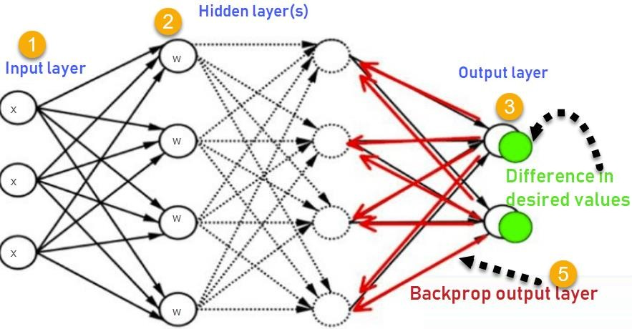

1. Inputs X, arrive through the preconnected path
2. Input is modeled using real weights W. The weights are usually randomly selected.
3. Calculate the output for every neuron from the input layer, to the hidden layers, to the output layer.
4. Calculate the error in the outputs

ErrorB= Actual Output – Desired Output

1. Travel back from the output layer to the hidden layer to adjust the weights such that the error is decreased.

#### Why We Need Backpropagation?

Most prominent advantages of Backpropagation are:

* Backpropagation is fast, simple and easy to program
* It has no parameters to tune apart from the numbers of input
* It is a flexible method as it does not require prior knowledge about the network
* It is a standard method that generally works well
* It does not need any special mention of the features of the function to be learned.

#### Disadvantages of using Backpropagation

* The actual performance of backpropagation on a specific problem is dependent on the input data.
* Backpropagation can be quite sensitive to noisy data
* You need to use the matrix-based approach for backpropagation instead of mini-batch.